**Whole Practice Assignment MongoDB**

1. Installed MongoDB on Windows.

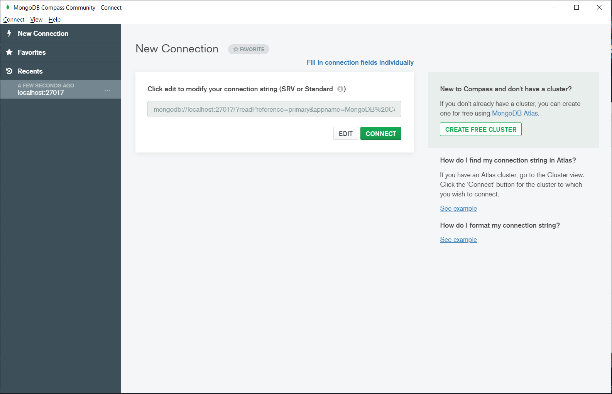

1. MongoDB server

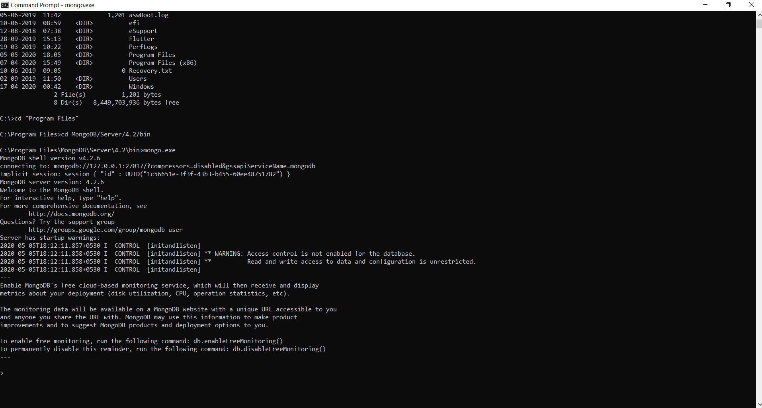

1. Creating Database

* use database_name

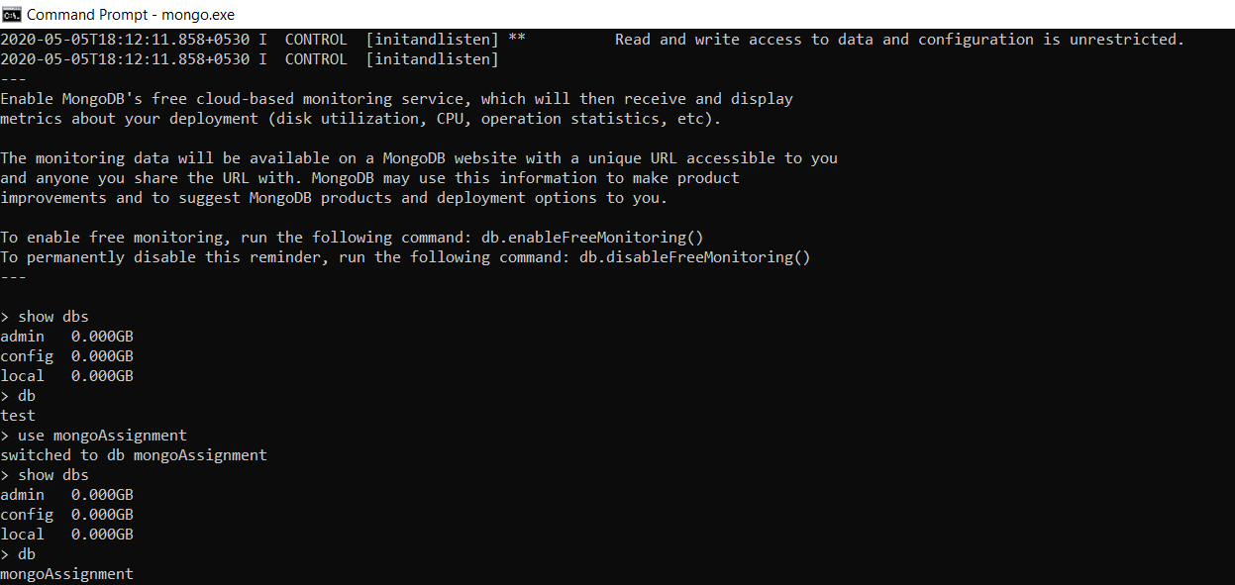

1. Insert Data into database with a proper document structure

* db.collection_name.insert({})



1. Database Successfully created with the above data

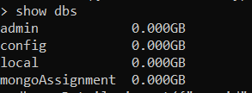

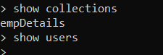

1. Display data in database

* db.collection_name.find()

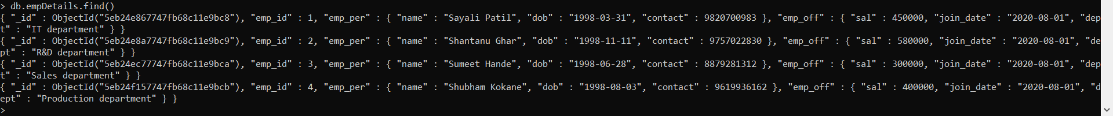

1. Commands used in mongo shell

* show roles : to display all the roles

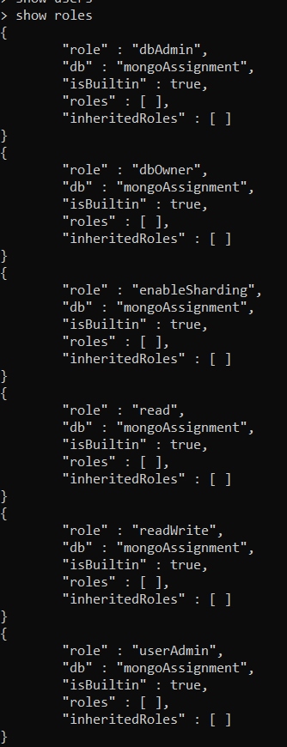

* show users : to display the list of users of that particular database



* show profile : Print the five most recent operations that took 1 millisecond or more

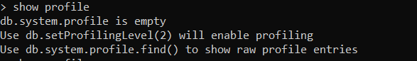

* db.help(): shows help for database methods

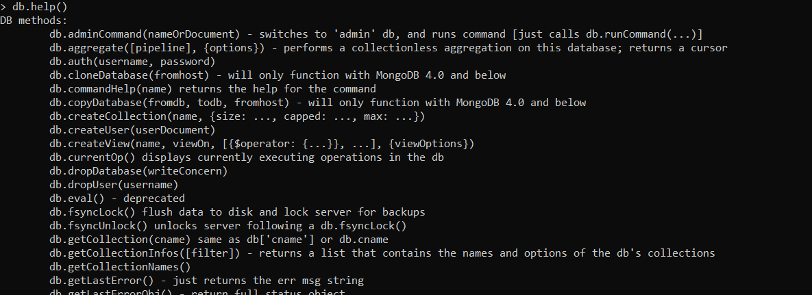

* db.collection_name.help() : help for collection methods

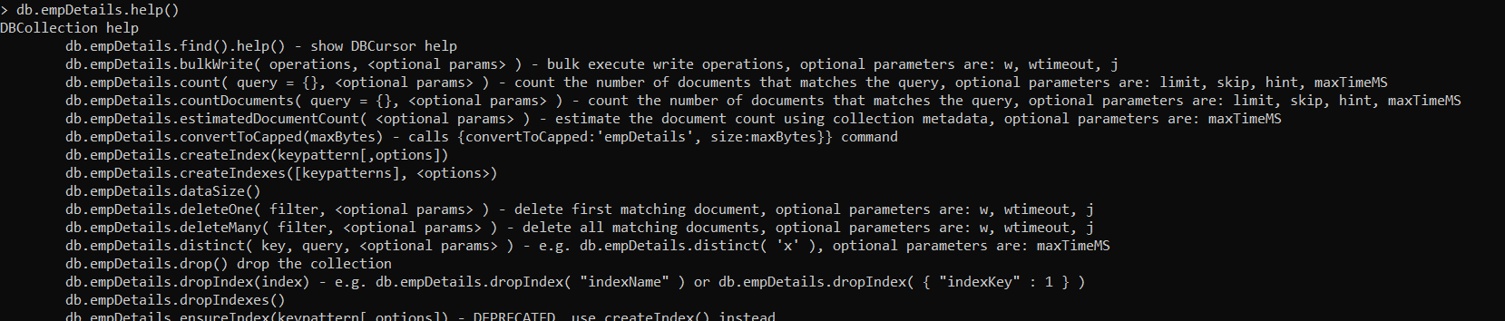

* show databases : Print a list of all available databases.

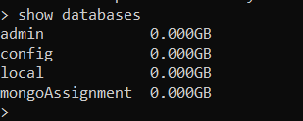

* load() : Execute a JavaScript file



1. Simple Queries on mongoDB

* db.collection_name.insert({}) : insert data into database



* db.collection_name.find() : to list all the data in the collection



* db.collection_name.find().pretty() : to display data with line breaks

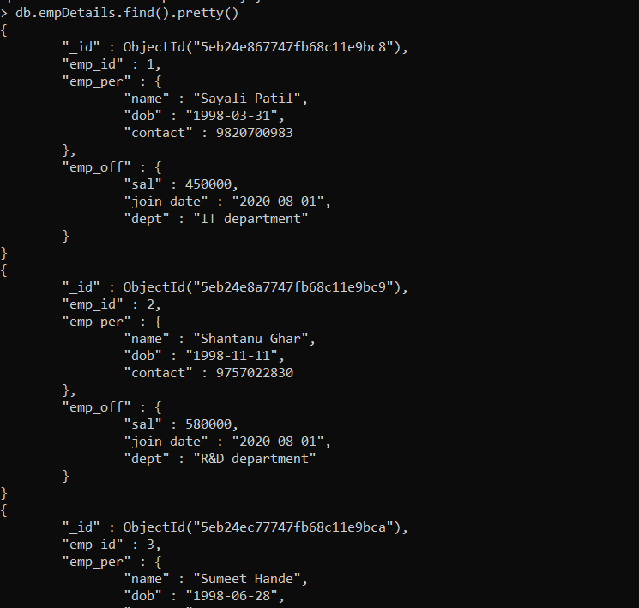

* db.collection_name.find({query}).pretty()

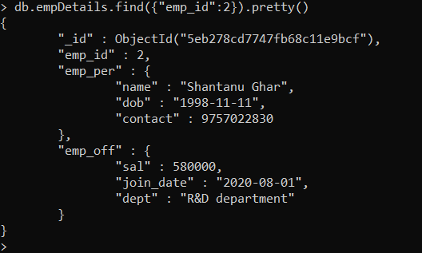

9)Create, update and delete

* db.collection_name.update({key : values_to_replace},{$set:{key: new_values}})

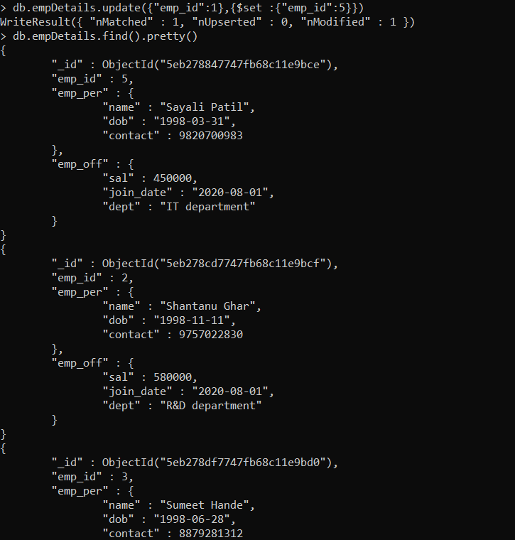

* db.collection_name.remove() : to delete entire data from collection
* db.collection_name.remove({query}) : to delete all records returned by the query

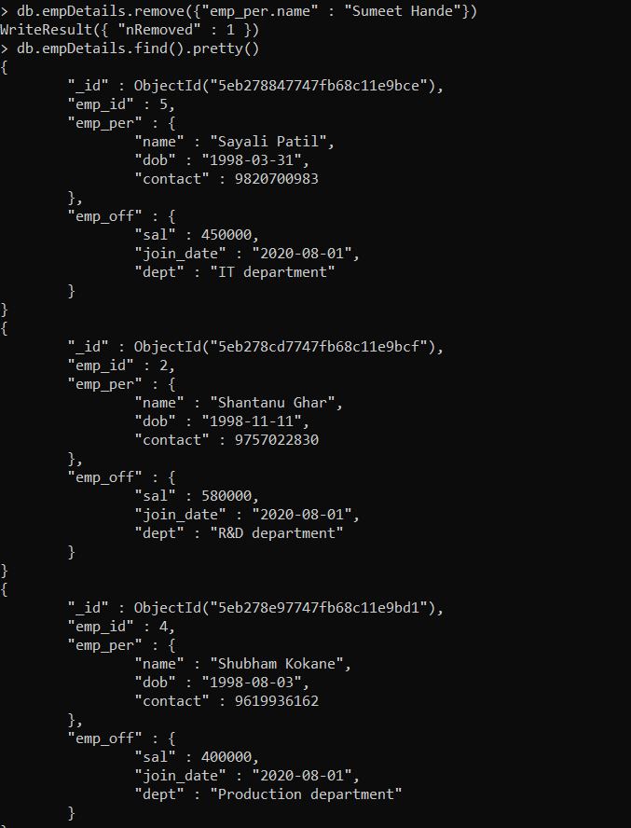

1. Scripting in mongoDB

* Using eval Flag

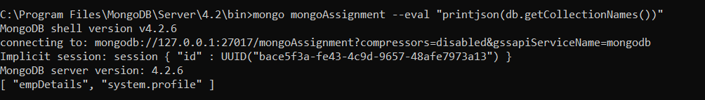

* Creating and running shell script

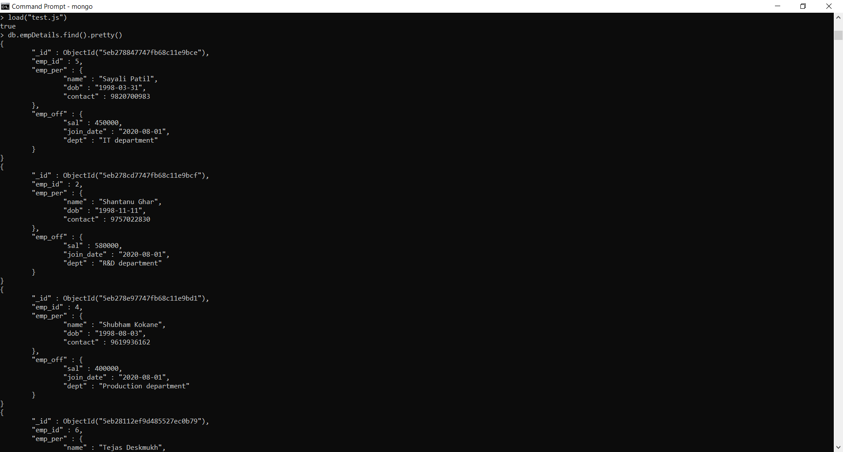

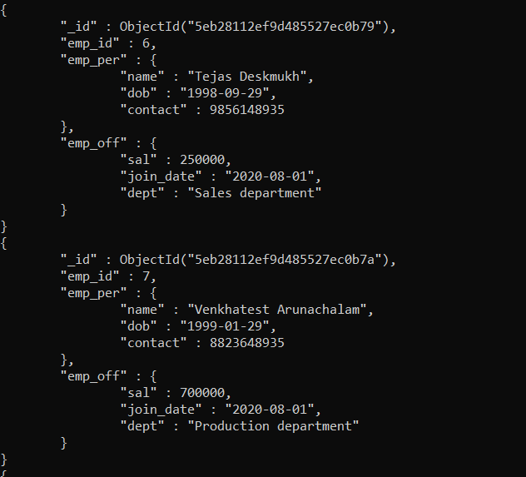

1. Using single purpose aggregation

* avg

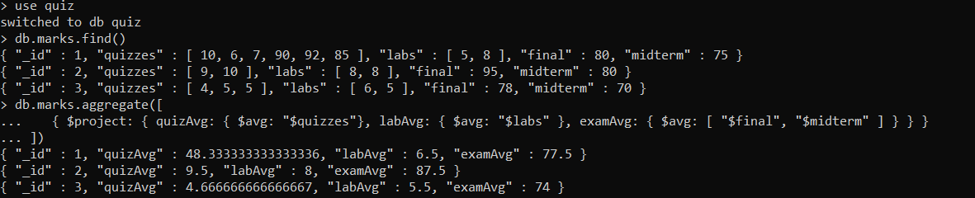

* push

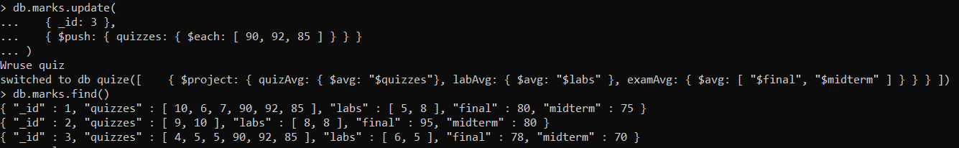

* sum

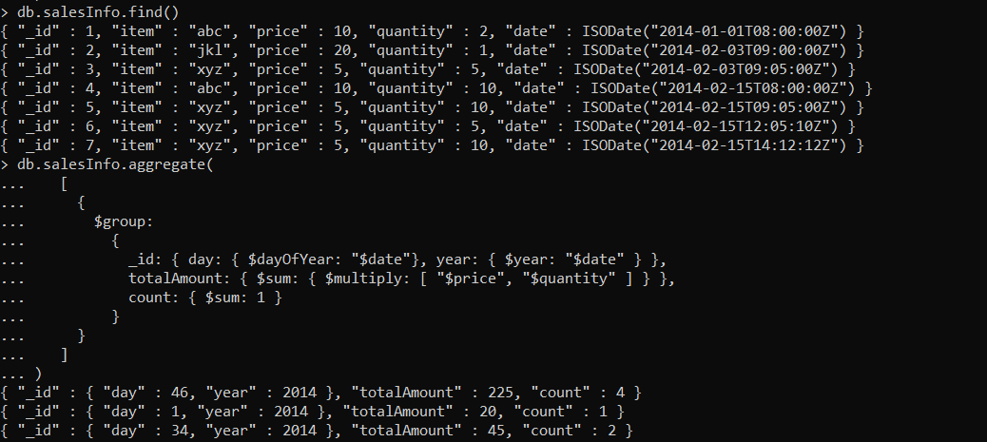

* first and last

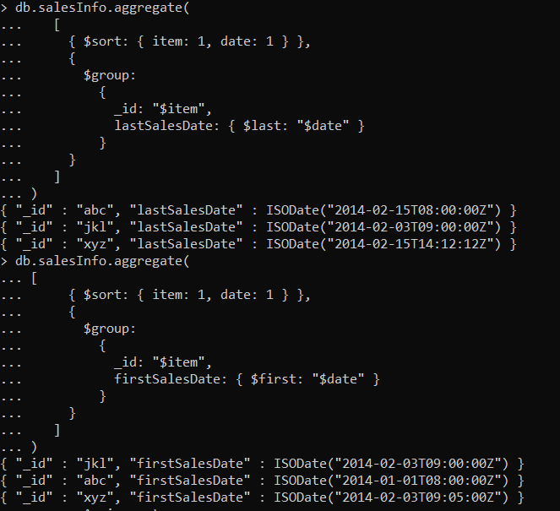

* AddToSet

